Do take care with these speed cameras! The first one is on a downhill section of a dual carriageway and can easily catch the unwary!

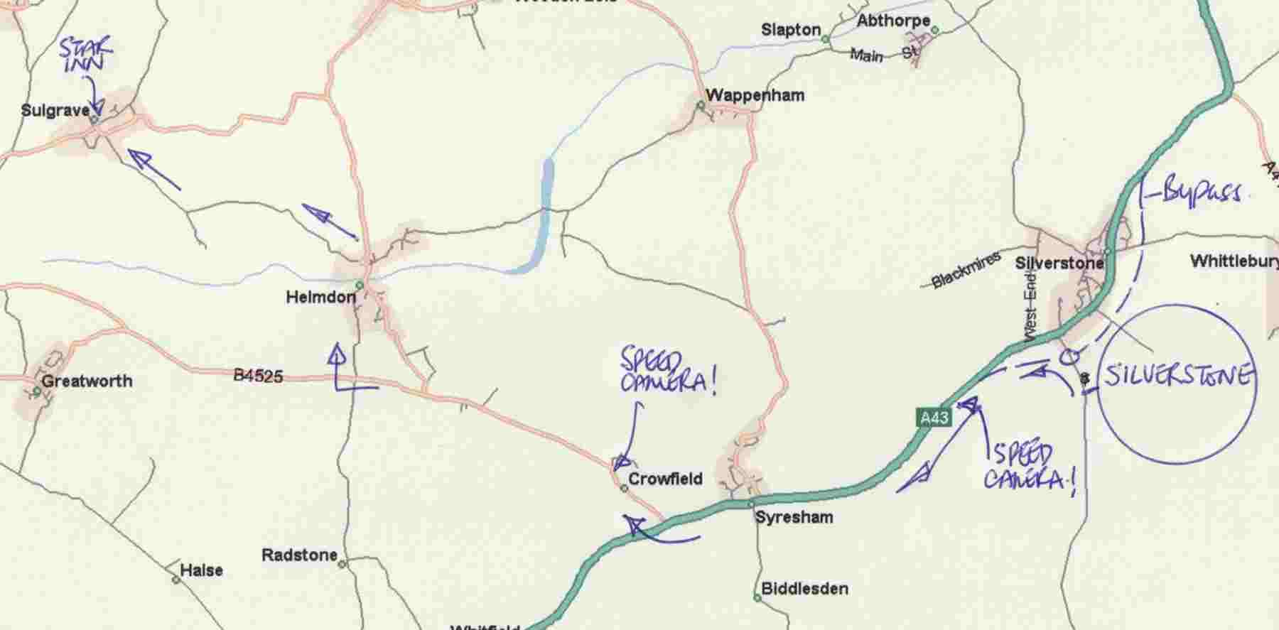

An informal supper at the Star Inn in Sulgrave village. Meet up in the bar with fellow V8 enthusiasts from around 6.45pm. This fine Hook Norton pub keeps its ale in a very good condition and has a splendid supper menu chalked up on a blackboard. If the weather is fine, supper in the garden is a memorable occasion but even if conditions require V8 members to remain in the bar, there are comfortable tables available on a first come first served basis. If you prefer, the Star has a dining room where you can reserve a table for supper.

