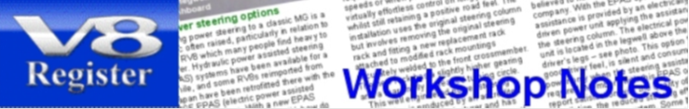

**Order form for workshop notes updates**

**What are workshop notes updates?**

Where Members have previously purchased a full set of workshop notes they often wish to update their set so they have a complete set of current notes. We have a simple way of providing updates of existing sets of workshop notes. Please note they are only available to V8 Register members who are current members of the MG Car Club and who have previously purchased a full set of the notes. There are two update options:

* **Updates of only the current volume and the previous volume of the series**. They are supplied as an email attachment in PDF format. There is no charge for these updates as email attachments.
* **Updated full sets** – where a member has purchased a full set many years ago clearly more updates will be necessary - an updated full set of workshop notes is available on a USB memory stick at a much reduced price.

**To qualify for an update let us know about your existing full set of notes**

The form below asks for the following information - which set of notes do you want to update, when did you purchase your existing set of workshop notes, what is the latest volume in your set of notes and what is the date in the footer of the PDF pages of the notes? Your current MG Car Club membership number is also required. Then simply send this form as an attachment to an email to the V8 Webmaster or send it by mail. We will then send you a link to a webpage where updates can be purchased.

**Details of your existing set of workshop notes**

Which set of notes do you have?

V8NOTES or RV8NOTES **>>**

Latest volume in that set of notes?

Volume number - example Volume 12 **>>**

Issue number & date in the footer?

See the footer of the pages in the latest

volume in your set of notes **>>**

**What update(s) do you want?**

Select one of the three options below:

**1** Complete set of workshop notes

V8NOTES? **>>**

RV8NOTES? **>>**..

**2** Update of current volume

V8NOTE Vol 15 **>>**

RV8NOTE Vol 2 **>>**

**3** Update including previous volume

V8NOTES Vols 13, 14 & 15 **>>**

RV8NOTES Vols 10, 11 & 12 **>>**

**Your details**

Member's name **>>**

MG Car Club membership

number **>>**

Postcode **>>**

Telephone **>>**

Email **>>**

MGV8 model owned

(Costello V8, MGBGTV8,

V8 Conversion or RV8) **>>**

**What happens next?**

When you send this form to the V8 Webmaster as an email attachment or by mail, the information regarding your previous set of notes and your membership information will be checked to ensure you have a valid claim to the updates offer.

If you have ordered your updates a new complete set of workshop notes then the V8 Webmaster will contact you to provide a link to a webpage where you can purchase a new complete set of workshop notes at the reduced Member only price.

If you have ordered updated recent volumes of the workshop notes then the V8 Webmaster will contact you on how the updates will be sent to you.

**Any queries, please contact the Victor Smith (V8 Webmaster)**