Chiltern Vintage Tractor Charity Run
***Thank you for your continued support***

In aid of the
Sunday 21st May 2017

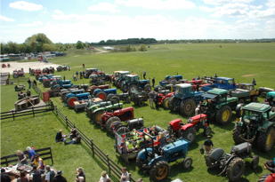
The run is approximately 22 miles (slightly shorter than last year) and is scheduled to take approx 6 hours and will start at 0930 hrs from a field next to the Chequers Pub in Fingest Oxon. RG9 6QD. (the actual field will be sign posted). Please note this is the same field as we have used the previous few years. The run is planned to terminate at approx. 1630hrs. Trailer and vehicle access will be provided but the security of any vehicles left will be the owner’s responsibility.
We do use public roads so please ensure that your machine is in a roadworthy condition, uses legal fuel and has the relevant Road Traffic Act Insurance, including third party public liability indemnity.
We ask that passengers are only permitted on tractors with factory fitted seats or in approved passenger carrying roadworthy trailers.
This year’s theme by popular demand is ‘Hawaiian Dress’ for you, any passengers and your trailer - there will be a prize for the best turnout
Once again we are participating in this event and ask if you would support us to raise funds for this very worthwhile cause.
Last year we raised about £1,500 it would be great if we could build on this, also if you wish to gift aid your donation/sponsorship please make sure we either have your post code or enter it on the form
This is the 11th Anniversary of the Chiltern Vintage Tractor Charity Run - our running total raised over the last ten events has been £34,395
For office use: ADV ID: IND

