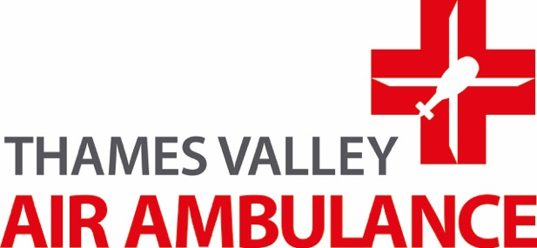

**Chiltern Vintage Tractor Charity Run**

**Boost your donation by 25p of Gift Aid for every £1 you donate!**

For example, a gift of £10 can be turned into £12.50 and it won’t cost you another penny!

**………………………………………………………………………………………………………………**

If you would like your donation to go further, just Gift Aid it by completing this form and send it back to:

**FREEPOST TVACAA** (This is all you need on your envelope) – Alternatively save us even more money by scanning and emailing it back to us at: info@tvairambulance.org.uk

I want to Gift Aid this donation, and any donations I make in the future, or have made in the past 4 years, to Thames Valley Air Ambulance. I am a UK tax payer, and understand that if I pay less Income Tax and/or Capital Gains Tax than the amount of Gift Aid claimed on all my donations in that year, it is my responsibility to pay any difference.

**\*\*\*PLEASE DO NOT FORGET TO TICK THIS BOX TO VALIDATE YOUR DECLARATION**

**If you pay income tax at the higher or additional rate** and want to receive the additional tax relief due to you, you must include all your Gift Aid donations on your Self Assessment tax return or ask HM Revenue & Customs to adjust your tax code.

Gift Aid is reclaimed by Thames Valley Air Ambulance from the tax you pay for the current tax year.

**Your address is needed to identify you as a current UK Tax Payer.**

Title First Name Surname

(e.g. Mr/Mrs/Miss/Ms/Dr)

Full Home

Address

Postcode Email

Signature Date

**PLEASE NOTIFY THE CHARITY IF:-**

1. you would like to cancel this declaration

2. you change your name or home address.

Registered Charity No. 1084910

3. you no longer pay sufficient tax on your income and/or capital gains