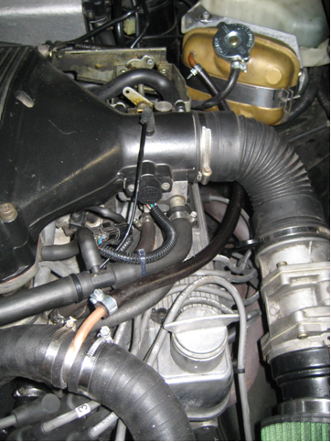
Rebuilding an MGBGTV8
RV8 owner Jon Buckley decided he would like to have an MGBGTV8 built and found a specialist that would take on the project. But what were the aims or intended outcomes for the project, why were certain features included as part of those aims (for example the extent of modifications and your feelings about subtle, technical improvements and/or more notceably upgrades like leather upholstery and mechanic changes), how did he find a V8 for the project, how did he choose the specialist to undertake the work, the budget and how did the project progress towards completion? Here Jon explains.
Text text text text text . . . continued.

Brief guide
Text text text text text.
Indent each new para three spaces, main text is 9pt Aerial, heading is 10 point Aerial and title is 12 point Aerial. The template can also be used to draft material for use by the V8 Scribe in a half page V8 Column or a four page V8 Newsletter with images in the Safety Fast! magazine.

Section heading
Text indent each para three spaces, main text 9pt Aerial and headings are 10 point Aerial. Note main heading for each article in the V8 Newsletter or V8 Column is in 11pt Aerial.

Update footer
Click keystrokes Alt V then H to go to the header and scroll down to footer.

Naming a file
Please use a standard format with reverse date, topic, description and revision number using hyphens between the text in the filename. This dating system ensures files are listed in the folder in date order and with a consistent topic. This is particularly helpful when files are sent to the Safety Fast! editor and onwards to the publisher when often time schedules are tight so finding material easily is essential. For example:
240815-carlift-options-review-v1.doc
Also please name digital image files using a similar topic and description format – for example:
240815-carlift-NSfront.jpg

Suggested drafting approach
Use the first paragraph to introduce the article, mentioning the contributor and highlighting what will be covered in the article or or the outcome. Avoid preambling at the beginning of a paragraph or even at the start of the article.
A pithy and interesting read can be achieved by placing the subject of each paragraph in the first half of the first sentence – for example:
The car lift options that Jim Greenhill considered were text text text . .

Image file sizes
Good quality digital image files are needed for reproduction in a full colour magazine like Safety Fast! so the minimum file sizes should be:
One column wide: 250KB (0.25MB).
Two columns wide 750KB (0.75MB).
Three columns wide: Over 1.5MB.
For reproduction in a PDF document on the V8 website lower quality image file sizes can be accepted.

